# Section 5.2: The Definite Integral

## Definition and Notation

The definite integral generalizes the concept of the area under a curve. We lift the requirements that $f(x)$ be continuous and nonnegative, and define the definite integral as follows.

If $f(x)$ is a function defined on an interval $[a,b]$, the **definite integral** of $f$ from $a$ to $b$ is given by

$\int_{a}^{b}{f(x)}dx=\lim_{n→∞}{\sum_{i=1}^{n}{f\left(x_{i}^{*}\right)}∆x}$

Provided the limit exits. If this limit exists, the function $f(x)$ is said to be integrable on $[a,b]$, or is an **integrable function**.

Although the notation for indefinite integrals may look similar to the notation for a definite integral, they are not the same. A definite integral is a number. An indefinite integral is a family of functions.

On the definite integral, above and below the summation symbol are the boundaries of the interval $[a,b]$. The numbers $a$ and $b$ are $x-$ values and are called the limits of integration; specifically, $a$ is the lower limit and $b$ is the upper limit.

**Continuous Functions Are Integrable**

If $f(x)$ is continuous on $[a,b]$, then $f$ is integrable on $[a,b]$.

Media: Watch this [video](https://youtu.be/gFpHHTxsDkI) example on using Reimann sum to evaluate a definite integral.

Example: Use the definition of the definite integral to evaluate $\int_{0}^{2}{x^{2}}dx$. Use a right-endpoint approximation to generate the Riemann sum.

## Evaluating Definite Integrals

Evaluating definite integrals with Riemann sums can be tedious due to the complexities of the calculations (evaluating definite integrals without taking limits of Riemann sums will be shown later). For now, know that definite integrals represent the area under the curve, and we can evaluate definite integrals by using geometric formulas to calculate that area.

Media: Watch this [video](https://youtu.be/jFC-yhECfWU) example on using shapes to find area.

Example: Use the formula for the area of a circle to evaluate $\int_{3}^{6}{\sqrt{9-{\left(x-3\right)}^{2}}}dx$.

## Area and the Definite Integral

When we defined the definite integral, we lifted the requirement that $f(x)$ be nonnegative. But how do we interpret “the area under the curve” when $f(x)$ is negative?

### Net Signed Area

Let $f(x)$ be an integrable function defined on an interval $[a,b]$. Let $A_{1}$ represent the area between $f(x)$ and the $x-$ axis that lies above the axis and let $A_{2}$ represent the area between $f(x)$ and the $x-$ axis that lies below the axis. Then, the **net signed area** between $f(x)$ and the $x-$ axis is given by

$\int_{a}^{b}{f(x)}dx=A_{1}-A_{2}$

Consider the example below. For a function that is partly negative, the Riemann sum is the area of the rectangles above the $x$-axis less the area of the rectangles below the $x-$ axis.

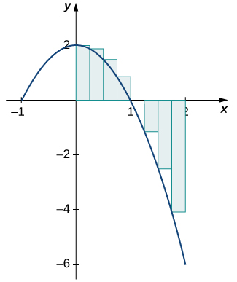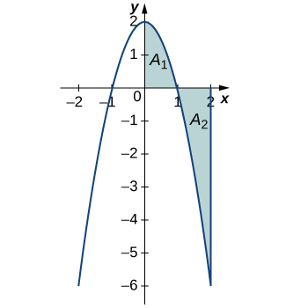

In the limit, the definite integral equals area $A_{1}$ less area $A_{2}$, or the net signed area.

Notice that the net area can be positive, negative, or zero. If the area above the $x-$ axis is larger, the net signed area is positive. If the area below the $x-$ axis is larger, the net signed area is negative. If the areas above and below the $x-$ axis are equal, the net signed area is zero.

Media: Watch this [video](https://youtu.be/sMxmu_lTeiQ?t=151) example on net signed area.

Examples

1. Find the net signed area between the curve of the function $f\left(x\right)=2x$ and the $x$-axis over the interval $[-3,3]$.
2. Find the net signed area of $f\left(x\right)=x-2$ over the interval $[0,6]$, illustrated in the image below.

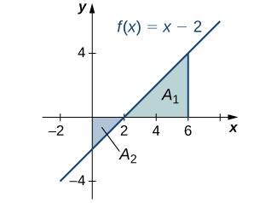

### Total Area

Let $f(x)$ be an integrable function defined on an interval $[a,b]$. Let $A_{1}$ represent the area between $f(x)$ and the $x-$ axis that lies above the axis and let $A_{2}$ represent the area between $f(x)$ and the $x-$ axis that lies below the axis. Then, the **total area** between $f(x)$ and the $x-$ axis is given by

$\int_{a}^{b}{\left|f(x)\right|}dx=A_{1}+A_{2}$

One application of the definite integral is finding displacement when given a velocity function. If $v(t)$ represents the velocity of an object as a function of time, then the area under the curve tells us how far the object is from its original position.

When velocity is constant, the area under the curve is just velocity times time. In the context of displacement, net signed area allows us to take direction into account. For example, if a car travels straight north at a speed of $60$ mph for $2$ hours, it is $120$ mi north of its starting position. If the car then turns around and travels south at a speed of $40$ mph for $3$ hours, it will be back at its starting position (a displacement of zero).

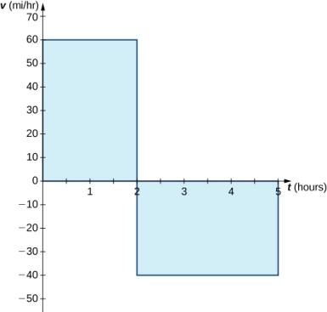

However, if we want to know how far the car travels overall (regardless of direction), we want to know the area between the curve and the $x-$ axis, regardless of whether that area is above or below the axis (i.e. total area).

Media: Watch this [video](https://youtu.be/KzTRPWmBm_s) example on finding total area.

Example: Find the total area between $f\left(x\right)=x-2$ and the $x$-axis over the interval $[0,6]$.

## Properties of the Definite Integral

The properties of indefinite integrals apply to definite integrals as well. Definite integrals also have properties that relate to the limits of integration. These help manipulate expressions to evaluate definite integrals.

**Properties of the Definite Integral**

1. If the limits of integration are the same, the integral is just a line and contains no area.

$\int_{a}^{a}{f(x)}dx=0$

1. If the limits are reversed, then place a negative sign in front of the integral.

$\int_{b}^{a}{f(x)}dx=-\int_{a}^{b}{f(x)}dx$

1. The integral of a sum is the sum of integrals.

$\int_{a}^{b}{[f\left(x\right)+g\left(x\right)]}dx=\int_{a}^{b}{f(x)}dx+\int_{a}^{b}{g(x)}dx$

1. The integral of a difference is the difference of the integrals.

$\int_{a}^{b}{[f\left(x\right)-g\left(x\right)]}dx=\int_{a}^{b}{f(x)}dx-\int_{a}^{b}{g(x)}dx$

1. For constant $c$, the integral of the product of a constant and a function is equal to the constant multiplied by the integral of the function.

$\int_{a}^{b}{cf\left(x\right)}dx=c\int_{a}^{b}{f(x)}dx$

1. Although this formula normally applies when $c$ is between $a$ and $b$, the formula holds for all values of $a,b$, and $c$, provided $f\left(x\right)$ is integrable on the largest interval.

$\int_{a}^{b}{f\left(x\right)}dx=\int_{a}^{c}{f(x)}dx+\int_{c}^{b}{f(x)}dx$

Media: Watch this [video](https://youtu.be/9FLYqh697xI) example on properties of definite integrals.

Examples

1. Use the properties of the definite integral to express the definite integral of $f\left(x\right)=-3x^{3}+2x+2$ over the interval $[-2,1]$ as the sum of three definite integrals.
2. Suppose that $\int_{0}^{4}{f(x)}dx=5$ and $\int_{0}^{2}{f(x)}dx=-3$, and $\int_{0}^{4}{g(x)}dx=-1$ and $\int_{0}^{2}{g(x)}dx=2$. Compute the following integrals:
$\int_{2}^{4}{\left(f\left(x\right)+g(x)\right)}dx$

$\int_{0}^{2}{\left(3f\left(x\right)-4g(x)\right)}dx$

3. Evaluate the integrals of the function graphed using the formulas for areas of triangles and circles, and subtracting the areas below the $x$-axis.

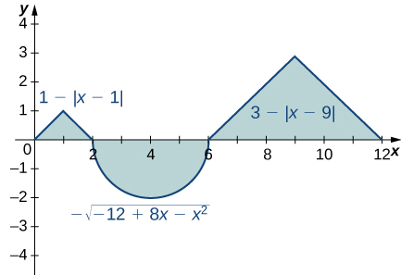

### Comparison Properties of Integrals

Comparing functions by their graphs as well as by their algebraic expressions can often give new insight into the process of integration. Intuitively, if a function $f(x)$ is above another function $g(x)$, then the area between $f(x)$ and the $x-$ axis is greater than the area between $g(x)$ and the $x-$ axis. This is true depending on the interval over which the comparison is made.

**Comparison Theorem**

If $f(x)≥0$ for $a≤x≤b$, then

$\int_{a}^{b}{f(x)}dx≥0$

If $f(x)≥g(x)$ for $a≤x≤b$, then

$\int_{a}^{b}{f(x)}dx≥\int_{a}^{b}{g(x)}dx$

If $m$ and $M$ are constants such that $m≤f(x)≤M$ for $a≤x≤b$, then

$m(b-a)≤\int_{a}^{b}{f(x)}dx$

$≤M(b-a)$

Example: Compare $f\left(x\right)=\sqrt{1+x^{2}}$ and $g\left(x\right)=\sqrt{1+x}$ over the interval $[0,1]$.

## Average Value of a Function

We often need to find the average of a set of numbers, such as an average test grade. However, if a function takes on an infinite number of values, we can’t use the process we normally use to find the average.

Let $f(x)$ be continuous over the interval $[a,b]$. Then, the **average value of the function $f\left(x\right) \left(or f_{ave}\right)$** on $[a,b]$ is given by

$f_{ave}=\frac{1}{b-a}\int_{a}^{b}{f(x)}dx$

Media: Watch this [video](https://youtu.be/GCGn2GBd1DE) example on average value.

Example: Find the average value of $f\left(x\right)=x+1$ over the interval $[0,5]$.